CS 2302 – Project 6, Option A  
Professor Diego Aguirre  
Victor Huicochea – 80643271

**Project 6**

**Introduction**

The purpose of this project is to practice the use of Topological Sort and Kruskal’s Algorithm. The lab should be an implementation of those algorithms and tested in a hard-coded graph.

**Proposed Solution**

Five different files were created to solve this lab. Two of them are classes; an Adjacency List Graph and a Queue. A file per algorithm was created as well; one for Topological Sort and another one for the Kruskal’s Algorithm.

Finally, the Main program simply creates two random graphs to test each algorithm. It prints on the screen the graphs before the implementation of the algorithm and prints it again once the algorithm has been applied.

Time Complexity

-Topological Sort: This sorting is basically depth-first search, which has a running time of O(V+E), where V is the number of vertices and E is the number of edges.

-Kruskal’s Algorithm: Sorting the edges takes O(ELogE). After sorting, the program checks all edges applying the find-union algorithm, which takes O(LogV). This means that the overall time complexity is O(ElogE + LogV) which can be reduced to O(ELogE).

**Experimental Results**

1.- Testing Topological Sort

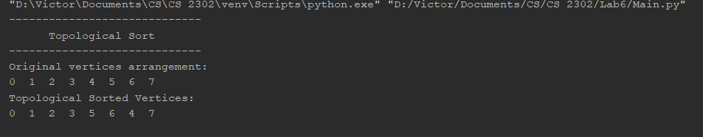

2.- Testing Kruskal’s Algorithm

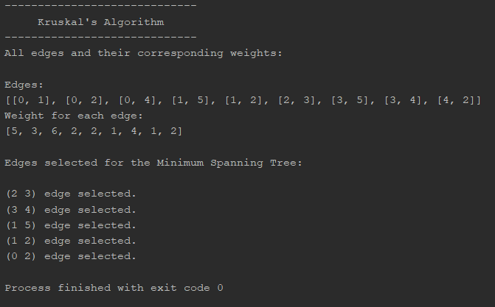

**Conclusions**

This project helped me to understand topological sort and Kruskal’s Algorithm. Now I feel more comfortable finding minimum spanning trees in graphs and visualizing their vertices and connections.

I also understood the graph data structure. This project helped me to visualize how data gets connected and I learned when it is a good idea to use graphs to represent data.

**Appendix – Source Code**

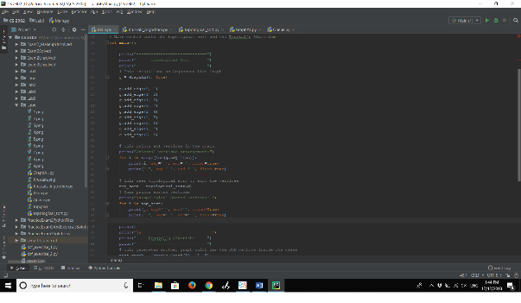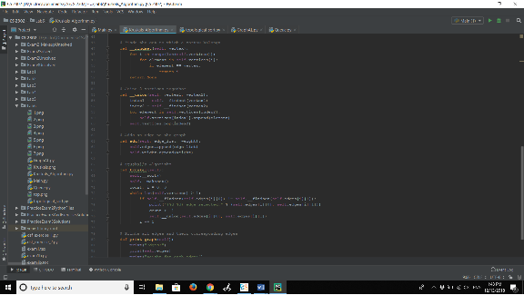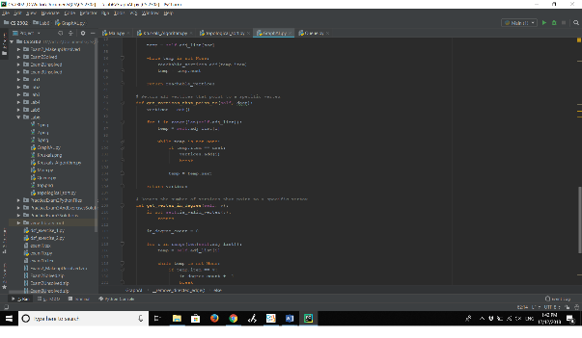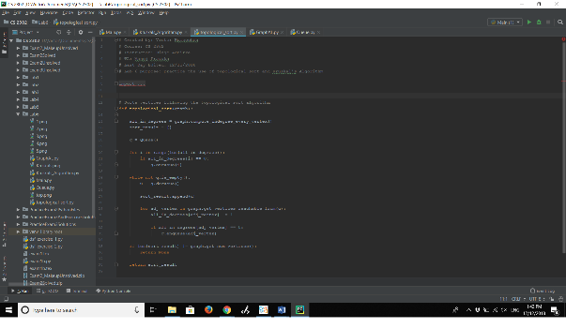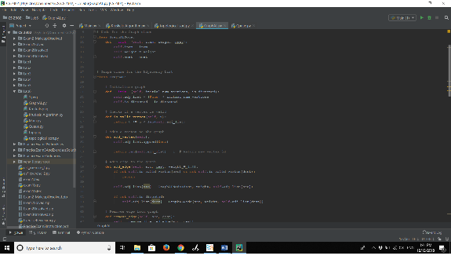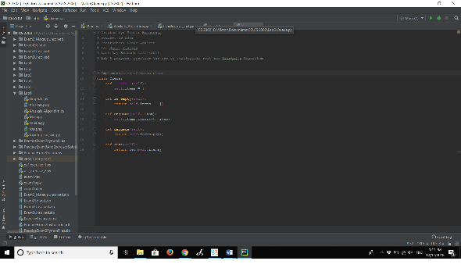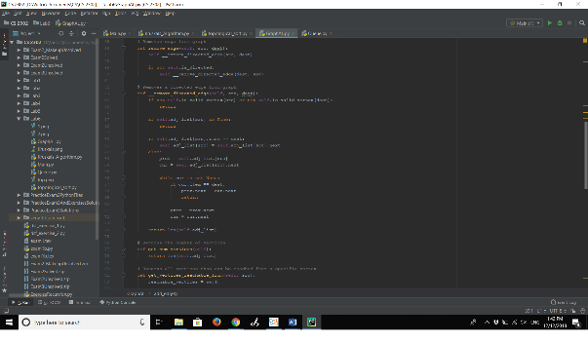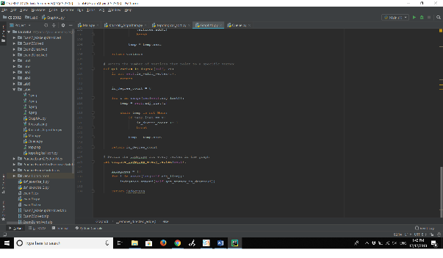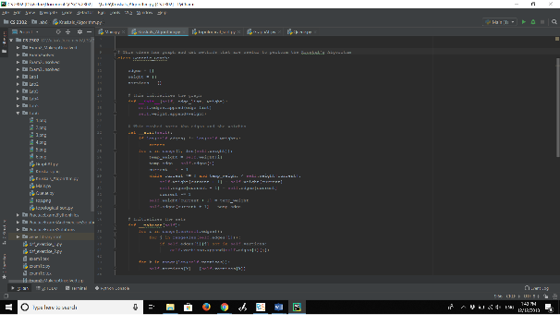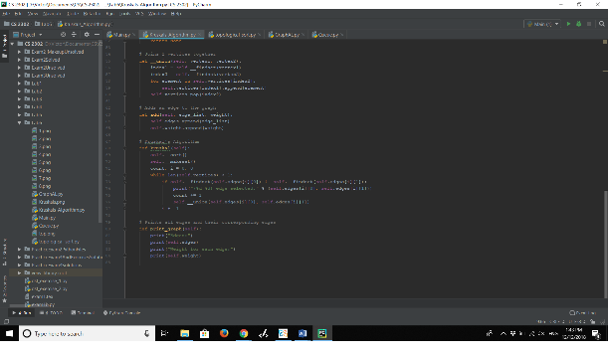

**Academic Honesty Certification**

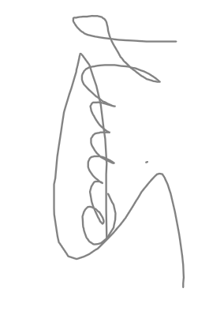I certify that this project is entirely my own work. I wrote, debugged, and tested the code being presented, performed the experiments, and wrote the report. I also certify that I did not share my code or report or provided inappropriate assistance to any student in the class.